EVNIRONMENTAL SETUP

|  |  |
| --- | --- |
| Date | Nov 2022 |
| Team ID | PNT2022TMID37600 |
| Project Name | CUSTOMER CARE REGISTRY |

FLASK SETUP:

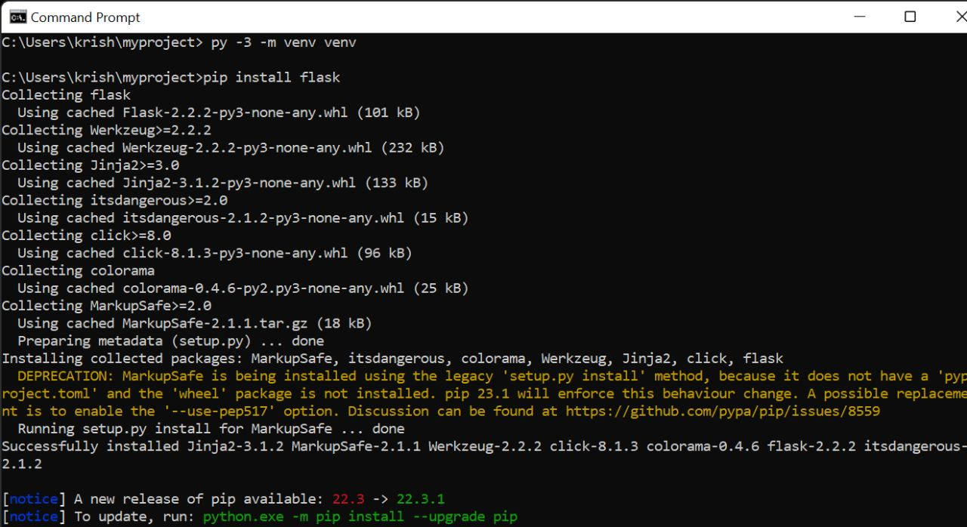

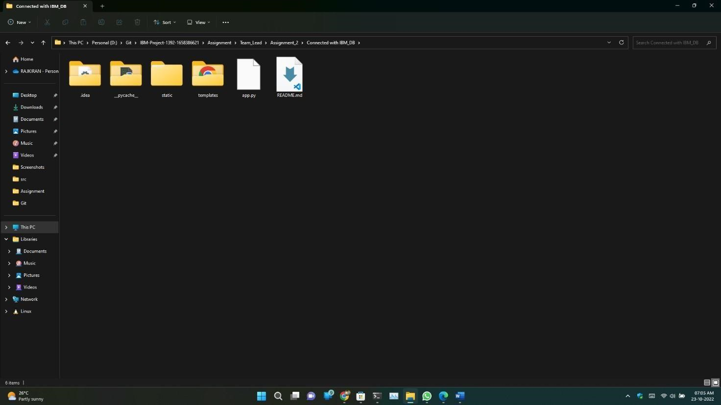

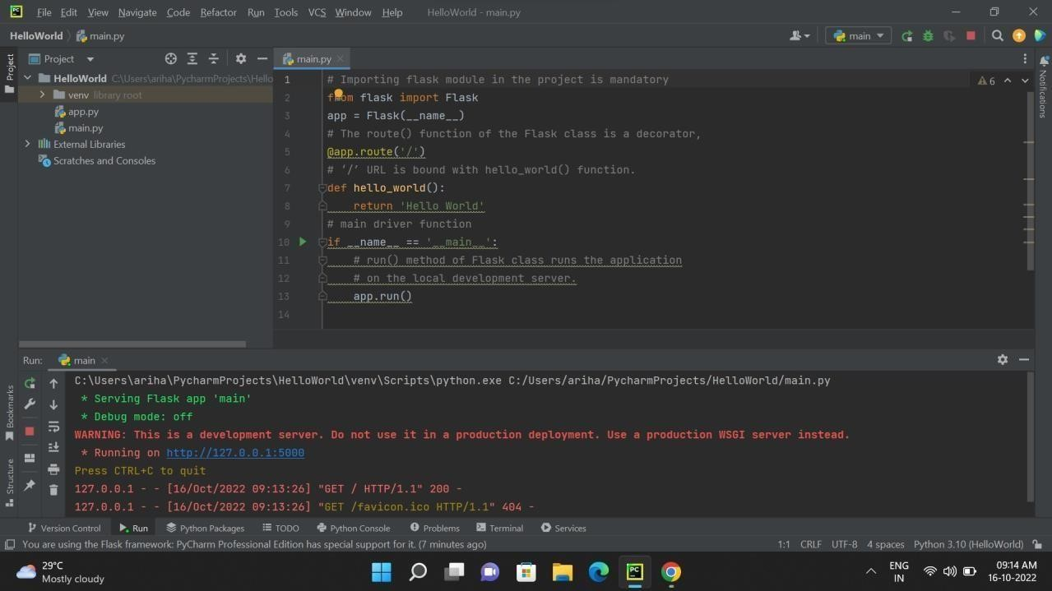

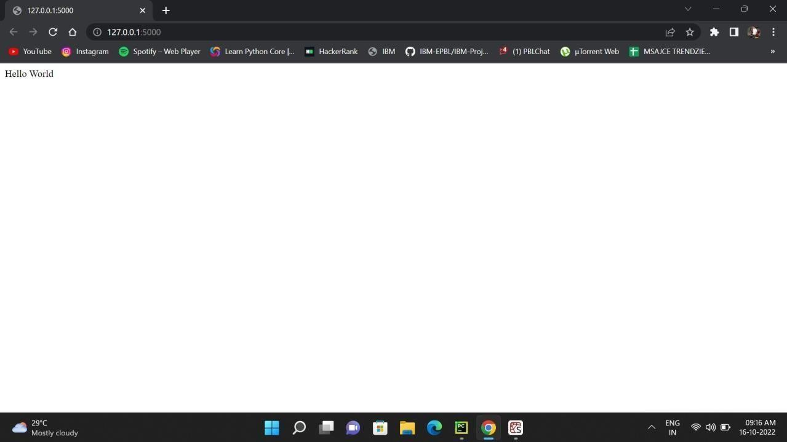

CLOUD ACCOUNT CREATION:

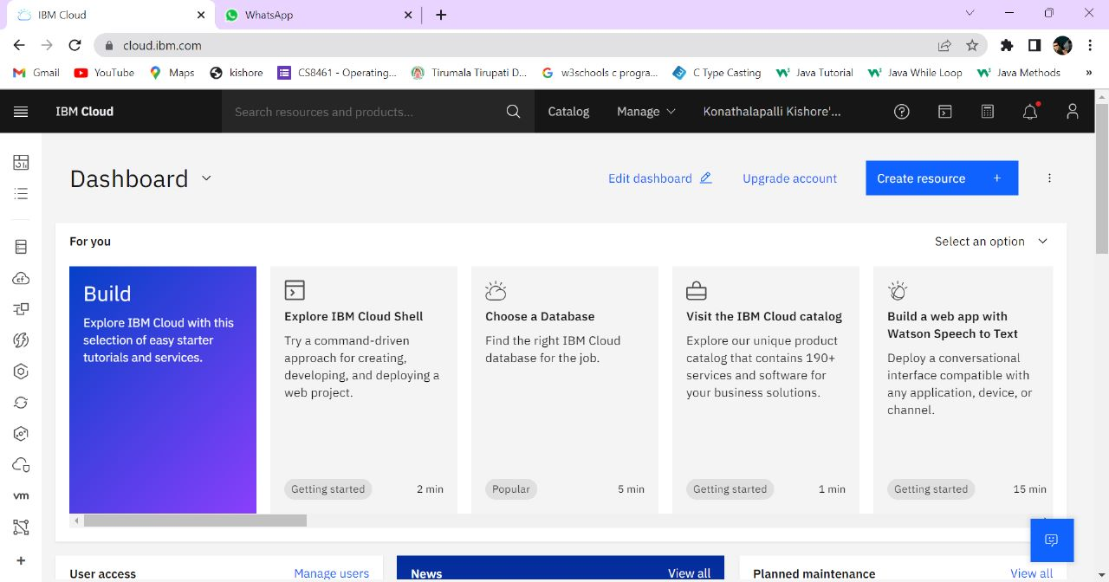

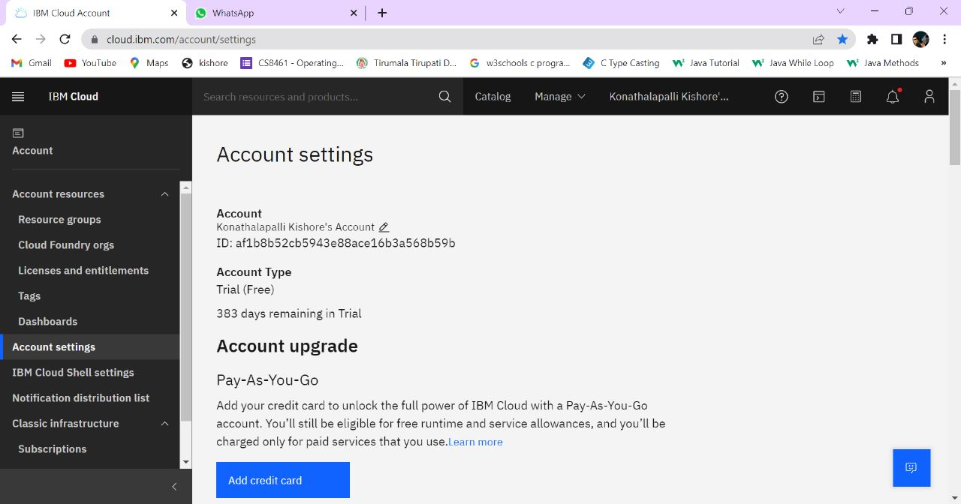

IBM CLOUD CLI INSTALL :

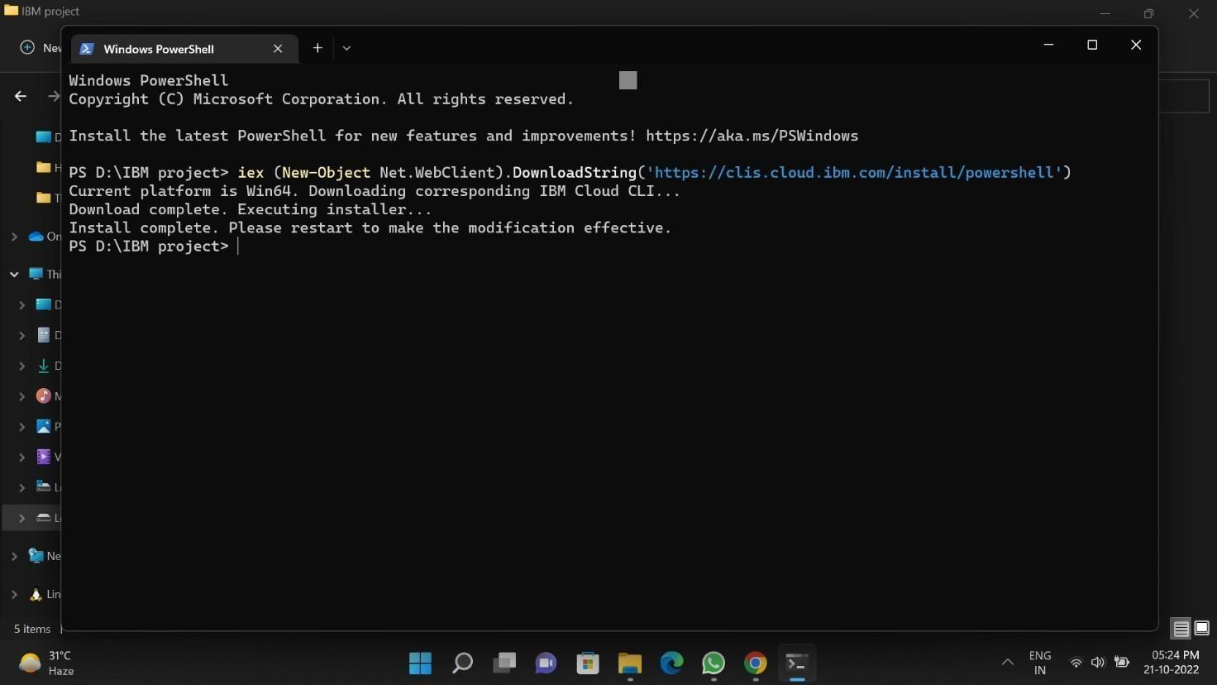

DOCKER SETUP:

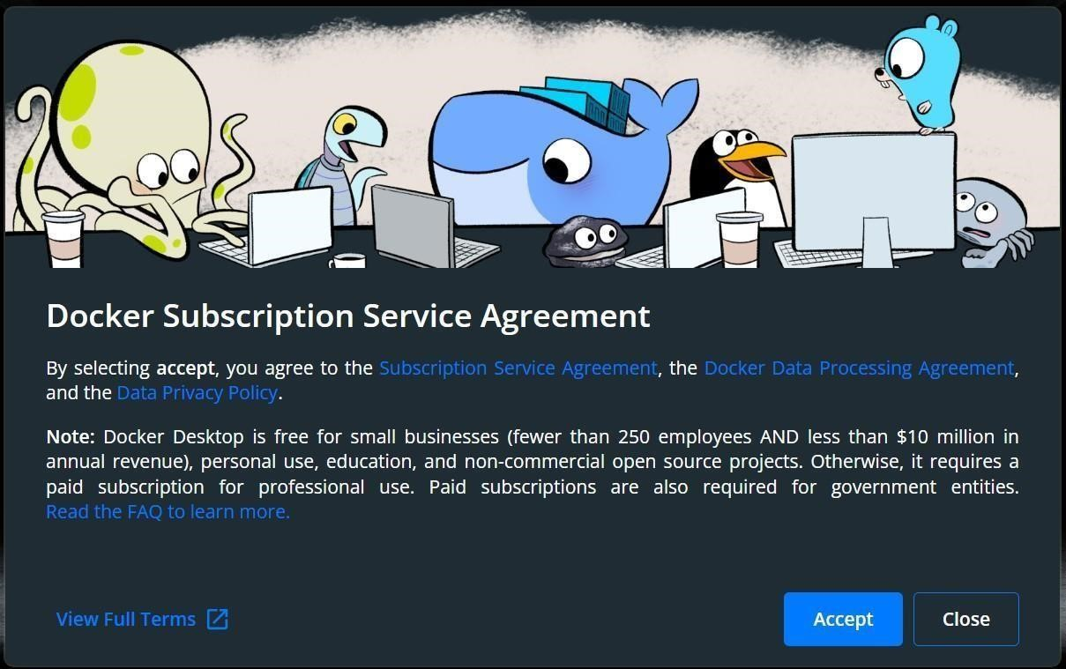

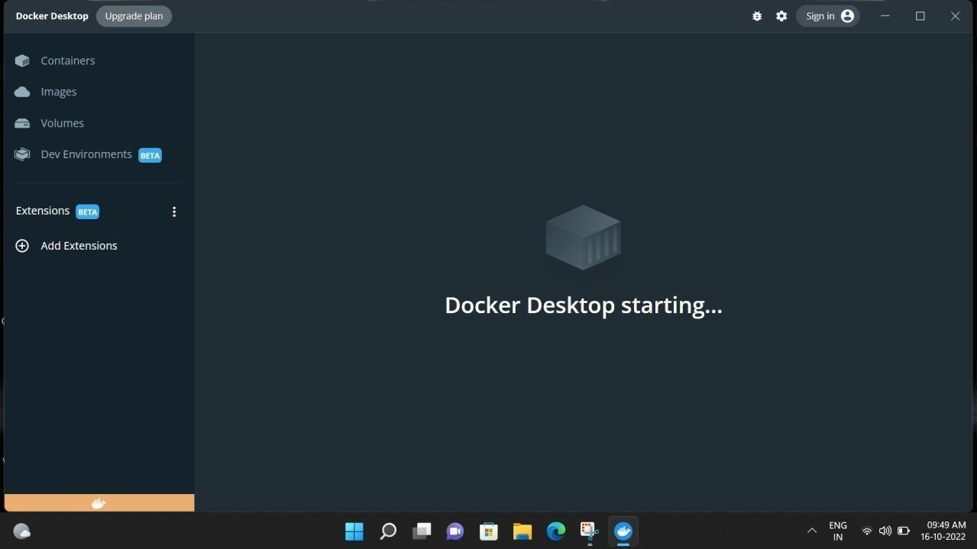

SENDGRID ACCOUNT CREATION:

